The following page(s) is provided so that you can use your preferred translation of the memory verse. Refer to the PDF version of this Activity Page to get an idea of how the text is laid out and arranged. Then use these pages to insert text and create an identical version of the Activity Page, using your preferred Bible translation.
WHAT TO DO:
Print and cut apart. Provide one set for each small group.

“Verse Words” Activity Page—Editable
September 2021, Week 4, Small Group K-5
©2021 The reThink Group, Inc. All rights reserved.

Text here
Text here

Text here
Text here

Text here
Text here

Text here

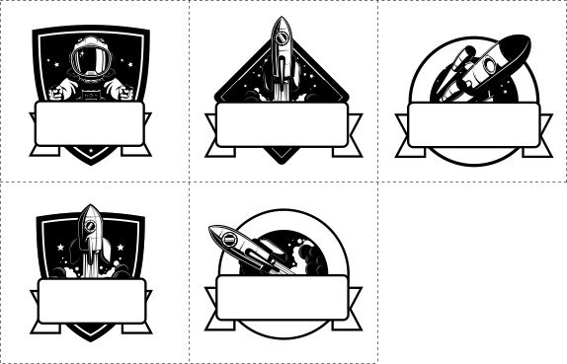

Text here
Text here

Text here
Text here

